**SPORT FACILITIES MANAGEMENT SYSTEM**

**DATABASE**

**MEHMET ÖRS**

**B2105.090156**

**ISTANBUL AYDIN UNIVERSITY**

**SOFTWARE ENGINEERING**

**SEN232 DATABASE SYSTEMS 2**

**CONTENTS**

1. **Introduction**
2. **Entities**
3. **ER Diagrams**
4. **Relationships, weak entities**
5. **Queries**
6. **Tables and Data**
7. **Table Creations - Data types**

**Introduction**

The sport facility management system database is designed to manage the operations of multiple sport facilities like membership and payment management, course registration, facility maintenance, event scheduling, keeping track of staff member’s schedule.

The system supports sport facilities of different types and for different sport types like football, basketball, volleyball, tennis, handball, swimming, diving, martial arts (karate, boxing, judo, taekwondo…), badminton etc., keeps track of the amenities information that are provided in the facility, like the amount of each amenity and the age restriction on them, stores information of the complexes that those facilities belong to, like the location of that complex, it’s social media etc.. It provides a comprehensive solution for managing and organizing the data of various aspects of sport facilities and complexes.

**Entities**

**ER DIAGRAMS**

**Cardinality:**

**Chen’s Notation:**

**Relationships:**

**Complex - Facility**

A complex must contain at least one, at most many facility.

A facility must belong to a complex.

**Complex - Social Media**

It's possible for a complex to have one or more social media accounts, but it's not a requirement.

A social media account must belong to a complex.

**Facility – Amenity**

A facility may have 0 or many amenities and an amenity be used in 0 or many facilities. We need the 3rd table facility_amenity to record this relationship.

**Member - Payment**

A payment is related to only 1 member and a member may not make any payment (maybe he gained a free membership) or make multiple payments (like each month). A payment can’t exist without a member who makes it, which makes payment a **weak entity**.A picture containing diagram

**Event – Sponsor**

An event may have 0 or 1 sponsor and a sponsor may finance 0 or many events.

**Facility – Sport type**

A facility must provide at least 1 and may provide many sport types.

A sport type may be provided in 0 or many facilities. Due to the many to many relationship, 3rd table is required.

**Member – Membership types**



A member must have a membership type.

A membership may not be registered or may be registered by multiple members. When a member is registering, a membership type should be chosen, so member entity totally participates to the relationship.

**Facility - Member**

A facility may have 0 or many members.

A member must be registered to only 1 facility.

**Facility - Course**

A course must be held at 1 facility

A facility may hold no courses or multiple courses.



**Course - Coach**

A coach may not lead a course or may lead multiple courses.

A course must be lead by 1 coach so course entity totally participates to the relationship.



**Course - Member**

Members may enroll to 0 or many courses.

Courses must have at least 1 member and can have many members.

Since the relationship is many to many, third table is required

**Course – Course schedule**

A course must have at least 1 and may have many schedule records so it totally participates.

A schedule must belong to 1 course and can’t exist without the course entity. So it is a **weak entity**.

**Staff – Coach**

A staff may or may not be a coach.

A coach must also be a staff and can’t exist without the staff record. So it is a **weak entity**.

**Facility – Staff**

A facility may have 0 or many staff.

A staff must belong to 1 facility.

**Facility – Availability**

A facility may or may not be available in different time lines.

An availability record must be associated with a facility and can’t exist without one. So it is a **weak entity.**

**Facility – Event**

Facility may host 0 or many events, where an event must be hosted at only 1 facility. So event entity participates.

**Member - Ranking**

A member may or may not rank the facility he is registered.

A ranking must belong to a member and can’t exist without one which makes it a **weak entity**.



**Queries**

**1-Average ranking rate of facilities located in Texas:**

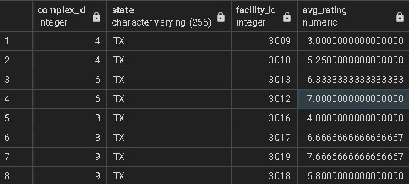

**Explanation:**

With the subquery (SELECT facility_id, AVG(rate) AS avg_rating FROM facility_rating

INNER JOIN member ON member.member_id = facility_rating.member_id

GROUP BY facility_id) AS facility_rank we first get the get the average rating of each facility.

And then joining the complex and facility tables with the new generated table facility_rank

using the facility_id attribute and display also the state and complex_id using complex table.

**2- Number of spots available in the badminton course:**

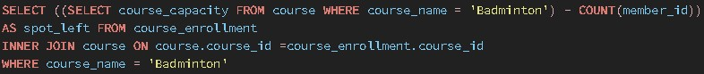

**Explanation:**

The sub subquery (SELECT course_capacity FROM course WHERE course_name = 'Badminton') returns the capacity of the course ‘Badminton’ and we subtract the number of members that are enrolled to this course using function COUNT(‘member_id’) from the course_enrollment and to get the name of the course and put the condition to the WHERE statement, we joined it with the course table.

**3- Facilities in Texas where fitness or swimming activities are available and open before 9 o’clock in the morning:**

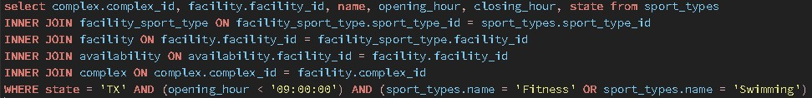

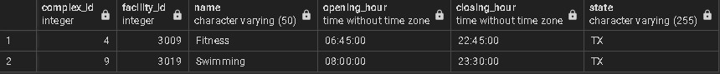

**Explanation:**

In this query we joined various tables together. sport_type to get the facilities that provides ‘swimming’ or ‘fitness’, facility_sport_type to join sport_type and facility, facility to join the tables complex and availability, availability to get the opening of the facilities that are open before 9 am and complex to get the complex_id and the state.

**4- Number of people who enrolled to swimming in year 2020:**

**Explanation:**

By joining the tables facility, facility_sport_type and sport_type, we get the facilities and the sport types they provide. By joining member and facility, we can get each member of facilities. With the new generated table, we can group by the course name which should be swimming in this case and get the corresponding number of members with COUNT(member).

**5- Second most expensive course in California:**

**Explanation:**

We get the course_cost values from the course table and state value from the complex table. To bridge them we use the facility table and after ordering the resulting table in descending order, by setting the OFFSET parameter of the LIMIT statement, we skip the first value and by limiting it to 1, we just get the second course_cost value.

**6- Courses that are currently ongoing and cost between 100 and 150 :**



**Explanation:**

Since the value of the end_date attribute is null for the courses that still continue, we can simply us the IS NULL condition for that attribute and the constraint on cost that has the value between 100 and 150.

**7-The facility which hosts the most events :**

**Explanation:**

To get how many events are hosted by each facility, we simply group by the COUNT(event_name) value with the facility_id. Then to get the maximum, we can order by the num_of_events in descending and limit it by 1.

**8- Payments made in 2021:**



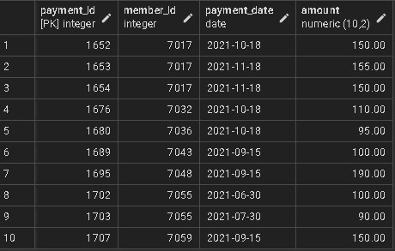

**Explanation:**

With the WHERE condition, we can simply put the BETWEEN keyword to specify that the payment_date values we are looking for is in 2021.

**9- Coaches that have more than 8 years of experience:**

**Explanation:**

With the condition years_of_experience >= 8 in WHERE condition, we can get the expected result.

**10- Number of members of that enrolled to each facilities after 2020:**

**Explanation:**

With the condition where date_join is later than January 1 of 2020 we get thexpected enrollments. Counting them for each of the facilities with the group by statement, we get the expected result.

**Tables:**

**Complex**

**Social Media**

**Facility**

**Member**

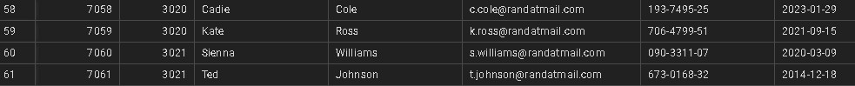

**Member Ranking**

Payments**

**Course**

**Course Enrollment**

**Coach**

**Staff**

**Course Schedule**

**Availability**

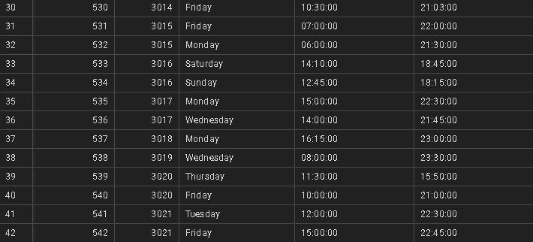

**Event**

**Sponsor**

**Amenity**

**Amenity – Facility**

**Sport Type**

**Facility-Sport Type**

**Tables Creations and Data Types**



